Report on Monitoring and Assessment: Ukraine, 2023

1. General Information

1.1 Number of cruises performed for monitoring and assessment of pollution in 2023

During 2023, as a result of hostilities and martial law, standard environmental monitoring within the exclusive maritime economic zone of Ukraine, including the area of the Danube coast and the waters of the open seas, was not conducted.
Therefore, the Report includes the results and studies of the quality of sea waters in samples that were selected by specialists at two stations of regular integrated monitoring of the water body CW5 in the area of "Cape Maly Fontan" and in area of the "Black Sea Yacht Club", also 4 statios in the area 13 Station Velykyi Fontan and the water body CW2 - one station in area village Primorske.

1.2 Number of stations (sampling points, maps)
The existing stations network of the ecological monitoring of Black Sea in 2023 included 7 stations. Description of these stations is presented in Table 1.1.
Locations of the stations are presented in Figure 1.1.

Table 1.1 - BSIMAP Stations in 2023
No St. | Name  St. | Latitude | Longitude | Location/Object of monitoring | Performer
1 | 1 | 46.4384 | 30.773 | Cape M.Fontan (CW5) | UkrSCES
2 | 1 | 46.4598 | 30.7654 | Black Sea Yacht Club (CW5) | UkrSCES
3 | 1 | 46.3982 | 30.7624 | 13 st.Velykyi Fountan (CW2) | UkrSCES
4 | 2 | 46.3951 | 30.7579 | 13 st.Velykyi Fountan (CW2) | UkrSCES
5 | 3 | 46.3935 | 30.7596 | 13 st.Velykyi Fountan (CW2) | UkrSCES
6 | 4 | 46.3994 | 30.7603 | 13 st.Velykyi Fountan (CW2) | UkrSCES
7 | 1 | 45.516906 | 29.641639 | village Primorske (CW2) | UkrSCES

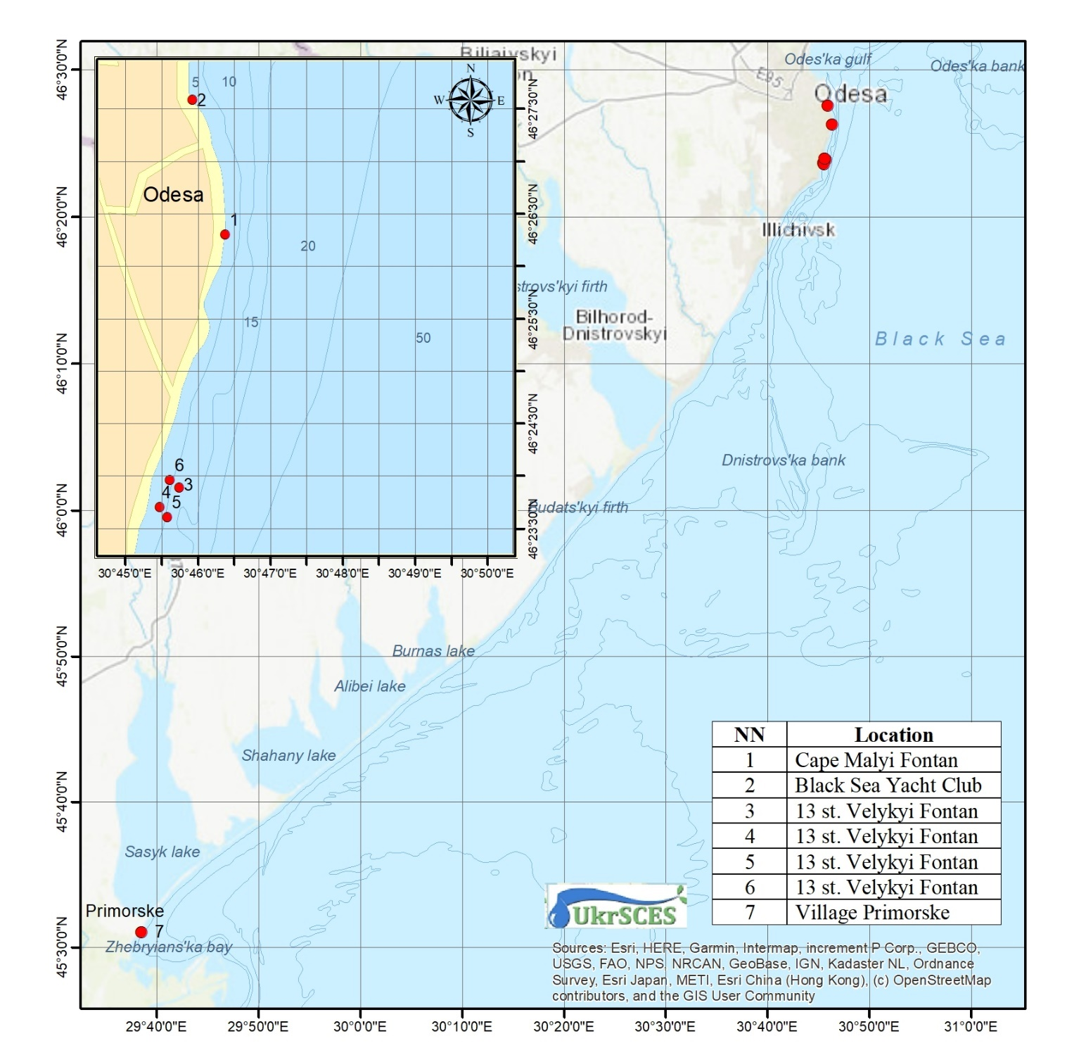
Figure 1.1 – BSIMAP stations of Ukraine in 2023

1.3 List of monitored parameters

List of monitoring parameters and number of performed samples in comparison with 2022 are presented in Table 2.1.

Table 2.1 - Samples numbers of Regional Ukrainian Monitoring Data in 2023/2022
Parameter | Samples numbers  (2023/2022) |  | Parameter | Samples numbers  (2023/2022) | Parameter | Samples numbers  (2023/2022)
Hydrochemicals (water) |  |  | Metals (water) |  | PAHs (water&bs)
Temperature | 63/31 |  | Fe | 7/5 | Naphthalene | 0/8 0/10
Salinity | 61/25 |  | Mn | 0/0 | Acenaphthylene | 0/8 0/10
pH | 63/31 |  | Zn | 7/5 | Fluorene | 0/8 0/10
O₂ | 63/31 |  | Co | 7/5 | Acenaphthene | 0/8 0/10
TSS | 0/0 |  | As | 7/5 | Phenanthrene | 0/8 0/10
Transparency | 0/0 |  | Hg | 7/5 | Anthracene | 0/8 0/10
BOD5 | 63/31 |  | Cu | 7/5 | Fluoranthene | 0/8 0/10
TOC | 0/0 |  | Cd | 7/5 | Pyrene | 0/8 0/10
H₂S | 0/0 |  | Pb | 7/5 | Benzo[a]antracene | 0/8 0/10
P(PO₄) | 58/31 |  | Ni | 7/5 | Chrysene | 0/8 0/10
P_{total} | 61/31 |  | Cr | 7/5 | Benzo(b)fluoranthene | 0/8 0/10
N (NH₄) | 63/31 |  | Al | 0/0 | Benzo(k)fluoranthene | 0/8 0/10
N (NO₂) | 58/31 |  | Other organic pollutants  (water) |  | Benzo[a]pyrene | 0/8 0/10
N (NO₃) | 61/31 |  | Phenols | 0/0 | Dibenzo[a,h]anthracene | 0/8 0/10
N_{total} | 63/31 |  | Detergents | 0/0 | Indeno(1,2,3-c,d)pyrene | 0/8 0/10
SiO₄ | 63/31 |  | TPHs | 22/0 | Benzo(ghi)perylene | 0/8 0/10
Chlororganic pesticides (water&bs) |  |  | PCBs total (water&bs) |  | Metals (bs*)
DDT |  | 7/8 0/0 | Ar1254 | 0/0 0/0 | Zn | 0/2
DDD |  | 7/8 0/0 | Ar1260 | 0/0 0/0 | Co | 0/2
DDE |  | 7/8 0/0 | PCB (37 ind.) | 7/8 0/0 | As | 0/2
Lindane |  | 7/8 0/0 |  |  | Hg | 0/2
α-HCH | 7/8 0/0 |  |  |  | Cu | 0/2
β-HCH | 7/8 0/0 |  |  |  | Cd | 0/2
HCB | 7/8 0/0 |  | Other organic pollutants (bs) |  | Pb | 0/2
Heptachlor | 7/8 0/0 |  | Phenols | 0/0 | Ni | 0/2
Aldrin | 7/8 0/0 |  | TPHs | 0/0 | Al | 0/2
Dieldrin | 7/8 0/0 |  | TOC | 0/0 | Fe | 0/2
Endrin | 0/0 0/0 |  |  |  | Cr | 0/2
* bs – bottom sediments

1.4 National institutions (laboratories) involved

- UkrSCES - the Ukrainian Scientific Centre of Ecology of the Sea, Ministry of the Environment Protection (Department of Analytical Research and Organization of Monitoring, actiong head Yurii Oleinik)

1.5 Data were reported to the Ministry of environmental protection and natural resources of Ukraine, Permanent Secretariat of the BSC.

1.6 Financing assured by Ministry of environmental protection and natural resources of Ukraine

Summary of quality control procedures routinely employed within the laboratory:

- Use of high-quality analytical standards for instrument calibration.
- Use of high-quality glassware, acids and other reagent and equipment.
- Routine calibration and adjustments of AAS and maintains of continuous records of these calibrations.
- Routine performance tests including complete procedural blank analyses and spikes.
- Use of certified reference material and performance of quality control chart.
- Use of replicate samples.
- Participation in Proficiency testing exercises

1.7 Names of authors of the annual report provided and names of those providing data:

Y. Denga, V. Komorin, Y. Oleinik, I. Tretyak, O. Miasnikova, O. Bratchenko, A. Titiapkyn

1.8 Participation in international conferences, seminars and meetings in 2023:

Research staff of UkrSCES participated in conferences, symposiums and workshops, a large part of which, due to the long quarantine and martial law, took place online:

1. Participation in the 62 meeting of the Bureau of the Intergovernmental Hydrological Program of UNESCO on 27-28 February 2023.
2. Participation in the 1st meeting of the working group from the Common Maritime Agenda for the Black Sea (CMA) under the Romanian Presidency. 03.06.2023.
3. Participation in the final meeting of the Working Group on the Development of the Agenda for Strategic Research and Innovation in the Black Sea (SRIA) within the framework of the EU Black Sea Connect project. April 12, 2023.
4. 134th Conference of the European Whaling Society. O Grove, Spain, April 17-20, 2023.
5. Participation in the All-Ukrainian seminar on the topic "Assessment of damage caused by Russian aggression to research and educational institutions in the field of studying the Black Sea and possible project solutions." 04.27.2023.
6. Participation in the regional seminar "Building the Blue Economy of the Black Sea: Partnership and Financing Opportunities", organized by the executors of the Common Maritime Agenda for the Black Sea. 05.10.2023/
7. 15 meeting of the ACCOBAMS Scientific Committee. Tunisia, May 9-11, 2023.
8. ASCOBANS Workshop to recommend small cetacean conservation objectives in relation to anthropogenic removals - Part 2 Bonn and online, 16-17 May 2023.
9. Participation in the consultation related to projects and initiatives regarding the SRIA implementation plan for the Black Sea, organized within the Black Sea CONNECT Project from March 14-17, 2023, Bucharest (Romania).
10. Participation in the meeting on the EFFECTIVE Project, organized within the framework of the EFFECTIVE Project #101112752 - "Increasing social welfare and economic prosperity by increasing the effectiveness of the protection and restoration of Mediterranean nature conservation areas" June 12-16, 2023. Brussels (Belgium).
11. Participation in the annual meeting of the MSFD Marine Litter Technical Group of the EU Marine Strategy Directive 2008/56/EC. June 21-22, 2023
12. Participation in the round table of the project "Implementation of knowledge and practices regarding the circular economy in the countries of the Black Sea basin" (BSB 1021 CIRCLECON). 21.07.2023.
13. Participation in the international event "Impact of the destruction of the Kakhovka HPP on the ecology and economy of the Northern Black Sea Region." 27.07.2023.
14. MSFD D1C1 Incidental Bycatch Working towards setting threshold values (online meeting 13.06.2023 and 15.09.2023).
15. Participation in the General Assembly of the Black Sea Network of Public Organizations from September 13-19, 2023 Varna (Bulgaria).
16. Participation in the high-level event - EuroSea Symposium on Ocean Observing and Forecasting, as a representative of Ukraine in GOOS (Global Ocean Observing System). 21.09.2023.
17. Participation in the General Assembly within the framework of the "BRIDGE-BS" project and the presentation of the results of the work within the budget topic No. 9 "Development of information support for the implementation of the tasks of the Maritime Strategy of Ukraine in 2023." September 27-28, 2023, Ankara (Turkey).
18. Participation in the 6th meeting of the Steering Committee of the BRIDGE-BS international project, which was timed to the International Black Sea Day. 31.10.2023
19. Participation in the international conference "Environmental Research between Ukraine and Bavaria - Encounter, Cooperation and Reconstruction" November 12-17, 2023, Regensburg (Germany).
20. Participation in an international educational trip within the framework of twin-city cooperation (Odesa-Heidelberg), organized by the National Youth Council of Ukraine, in partnership with the National Youth Council of Germany and the German Foreign Affairs Ministry November 21-27, 2023, Heidelberg (Germany).
21. Participation in an online meeting to discuss the current tasks of the WP9 package and "Brainstorming" within the framework of the "BRIDGE-BS" project. 01.12.2023
22. Participation in a training seminar on determining the age of gastropod molluscs, in particular rapana, December 11-14, 2023, Istanbul (Turkey).
23. Workshop on determining the age of Rapana venosa (Valenciennes, 1846) as part of the BlackSea4Fish scientific project coordinated by GFCM on December 11-14, 2023, Istanbul, Turkey.
24.Conference on the organization and creation of the DORIAN project task within the framework of HORIZON-MISS-2023-OCEAN-01-02.
25. ACCOBAMS Webinar - Regional training on genetic data collection and analysis - with a view to disseminate ACCOBAMS Best practices on cetacean population genetics.

1.9 Publications in 2023

- V. Vyshnevskyi, S. Shevchuk, V. Komorin, Y. Oleynik, P. Gleick. The destruction of the Kakhovka dam and its consequences. Water international 48 (5), 631-647.
- Viktor Vyshnevskyi, Alexander Matygin, Viktor Komorin. THERMAL REGIME OF THE NORTHWESTERN PART OF THE BLACK SEA. Geographia Technica, Vol 18, Issue 1, 2023, pp. 29-38.
- Aleksandr F. Krakhmalnyi, Maxim A. Krakhmalnyi, Galyna Terenko, Igor V. Goncharenko. Dominant Species of the Genus Protoperidinium Bergh (Peridiniales: Protoperidiniaceae) in the Black Sea // Zootaxa, 2023, 5339 (5), pp.427-488. DOI: 10.11646/zootaxa.5339.5.2⟩ ⟨hal-04204169⟩
- Krakhmalnyi, Maxim, Krakhmalnyi, Aleksandr, Terenko, Galyna (2023): Protoperidinium Euxinum (Protoperidiniaceae, Dinophyceae) - A Novel Dinoflagellate Species From The Plankton Of The Black Sea. // Phytotaxa 598 (3): 229-236, DOI: 10.11646/phytotaxa.598.3.4, URL: http://dx.doi.org/10.11646/phytotaxa.598.3.4.
- Popov D., Meshkova G., Vishnyakova K., Ivanchikova J., Paiu M., Timofte C., Öztürk A., Tonay A., Panayotova M., Düzgüneş E., Gol’din P. Mar. 2023. Assessment of the bycatch level for the Black Sea harbour porpoise in the light of new data on population abundance. Frontiers in Marine Science. 10:1119983. doi: 10.3389/fmars.2023.1119983 (Scopus, Q1).
- Aiken, M., Gladilina, E., Çakırlar, C., Telizhenko, S., van den Hurk, Y., Bejenaru, L., Olsen, M.T. & Gol’din, P. 2023. Prehistoric and historic exploitation of marine mammals in the Black Sea. Quaternary Science Reviews. 314. 108210. (Scopus, Q1).
- Ivanchikova J, Tregenza N (2023). Validation of the F-POD—A fully automated cetacean monitoring system. PLoS ONE 18(11): e0293402. https://doi.org/10.1371/journal.pone.0293402 (Scopus, Q1).
- N. ULUDUZ, K. VISHNYAKOVA, M. SÖZEN. Records of atypical pigmented bottlenose dolphins (Tursiops truncatus) at the south-western coast of the Black Sea (Zonguldak, Türkiye). Turkish Journal of Zoology 47 (5), 319-323.
- Protsenko Y, Kovalenko P, Salganskiy O, Gogol S, Pugovkin A, Dzhulai A, Tkachenko V, Svetlichniy L, Nabokin M, Kozeretska I, Convey P (2023). Records of Boeckella poppei (Mrazek, 1901) (Calanoida: Centropagidae) obtained during Ukrainian Antarctic Expeditions. Ukrainian Antarctic Journal, 21(1(26), 55-65. Occurrence dataset https://doi.org/10.15468/e6f3my accessed via GBIF.org on 2024-01-07.
- Pallin, L.J., Kellar, N.M., Steel, D., (...), Steinberg, D.K., Friedlaender, A.S. A surplus no more? Variation in krill availability impacts reproductive rates of Antarctic baleen whales. Global Change Biology. Volume 29, Issue 8, Pages 2108 – 2121. April 2023.
- Pavel Gol'din, Maria Ghazali, Svitozar Davydenko, Valeriia Telizhenko, Pavlo Otriazhyi, Karina Vishnyakova, Maia Bukhsianidze, Azucena Solis-Añorve, Igor Dzeverin. A whale humerus ironically shaped by neutral evolution and morphological integration. NaturePortfolio. Version 1, posted 27 Nov, 2023.
- González-Fernández, D., Cózar, A., Hanke, G., (...), Suaria, G., Tourgeli, M. Author Correction: Floating macrolitter leaked from Europe into the ocean (Nature Sustainability, (2021), 4, 6, (474-483), 10.1038/s41893-021-00722-6). Nature Sustainability. Volume 6, Issue 5, Pages 611. May 2023.
- Y.S. Tuchkovenko, D.V. Kushnir, V.A. Ovcharuk, A.V. Sokolov, V.N. Komorin. Characteristics of Black Sea dispersion of freshened and polluted transitional waters from the Dnipro-Bug estuary after destruction of the Kakhovka Reservoir dam. Ukrainian hydrometeorological journal, 95-114.
- Ю.С. Тучковенко, Д.В. Кушнір, В.А. Овчарук, А.В. Соколов, В.М. Коморін. Особливості розповсюдження в Чорному морі розпріснених і забруднених перехідних вод з Дніпровсько-Бузького лиману після руйнування греблі Каховського водосховища. Український гідрометеорологічний журнал 32, стр. 95-114.
- В.М. Коморін. Теоретико-методологічні аспекти управління екосистемними ризиками моря. Український гідрометеорологічний журнал 31, 33-54.
- O.A. Shchiptsov, O.Y. Goncharov. European research project on the state of pollution in the Black Sea «Black Sea SIERRA»: mission and partic ipation of Ukrainian oceanographers. Geofizicheskiy Zhurnal 45 (6)
- О.А. Щипцов, О.Ю. Гончаров. Участь українських вчених у дослідженнях стану забруднення західної частини Чорного моря у рамках проєкту «Black Sea SIERRA». Геофизический журнал 45 (6), 162-171.
- O. Goncharov. Variability of the Danube River Flow Affects the Distribution of Chlorophyll in the North-Western Black Sea. Tackling Present & Future Environmental Challenges of a European Riverscape, 45.
- ACCOBAMS 2022. ACCOBAMS Best Practices on Cetacean Population Genetics. Version 1, October 2022. By Gauffier, P., Schleimer, A., Carvalho, I., Chaieb, O., Donovan, G., Fontaine, M., Fraija, N., Genov, T., Gol’din, P., Lupše,N., Mazzariol, S., Méndez Fernández, P., Panti, C., Salivas, M., Tardy, C., Tonay, A., Vishnyakova, K. 94p.
20. Є.К. Полежаєв, А.С. Тітяпкин, Ю.М. Диханов. Просторово-часова змінність температури поверхневого шару води Чорного та Азовського морів. Океанографічний журнал (Проблеми, методи та засоби досліджень Світового океану), 5(16) 2023, стр. 49-59.

2 State of the Environment

Climate change in recent decades has exacerbated the negative environmental manifestations of anthropogenic impact on the marine environment. First of all, this applies to the northwestern part of the Black Sea (NWBS).
Climate change is more evident in both the increase in air temperature and the temperature of sea water, which is especially noticeable in the example of the NWBS since the 90s of the last century (Figure 2.1).

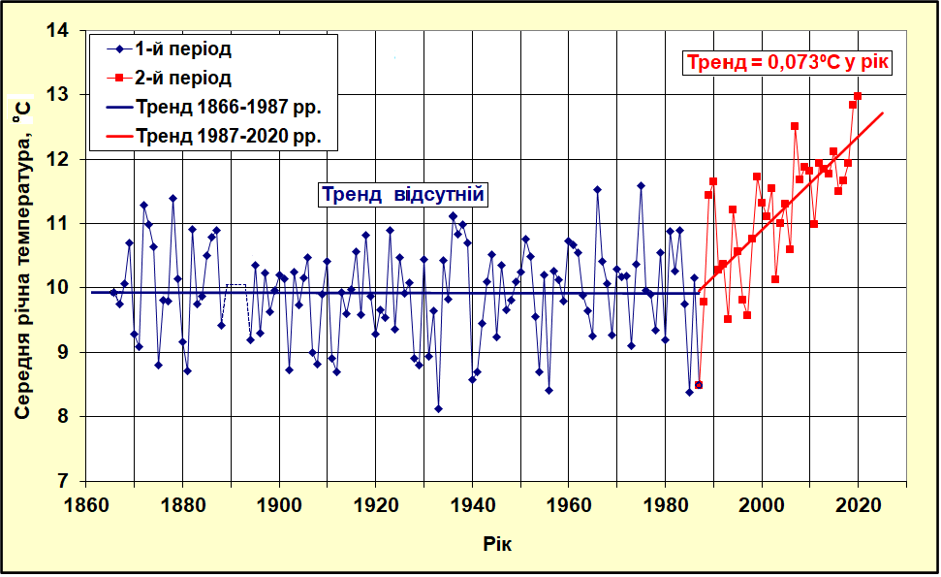
a) b)
Figure 2.1 – Long-term variability of the average annual air temperature at the NWBS (a) and temperature of sea water (b) according to the data of long-term observations of the Odesa-port HMS (hydrometeorological service).

In 2023, the average water temperature, according to the Odesa-port HMS, was 14.2 ºC, the air temperature was 13.3 ºC. Over the past ten years, as a result of this trend, the duration of the ice period has decreased by 1.5-3 decades. The last time ice was observed off the coast of Odesa, according to the observations of the Odesa-Port HMS, was in February 2018.
In 2023, the amount of precipitation was 489 mm, with the norm being 462 mm.
The salinity regime of surface waters, especially on the shallow shelf, is significantly influenced by river runoff, precipitation, temperature and wind regimes, which form the circulation and transport of water. The linear trend in Figure 2.2 shows an increase in salinity at a rate of 0.005 psu per year.
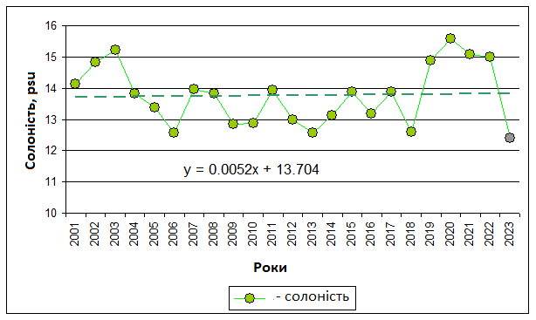
Figure 2.2 – Variability of salinity in the 21st century based on observations
by the Odessa-Port HMS

The average salinity of sea water according to the Odesa-port HMS in 2023 was 12.6 psu with a thirty-year norm of 13.95 psu. Such a decrease in salinity is primarily due to the destruction of the Kakhovka HPP dam in June 2023. This accident at the Kakhovka HPP significantly affected the ecological situation of the marine environment of the NWBS.
3 POLLUTIONS of marine environment

The state of the sea water was assessed by such pollutants as: toxic metals (TM), organochlorine pesticides (OHPs), polychlorinated biphenyls (PCBs) and polyaromatic hydrocarbons (PAHs).
Since the conduct of monitoring studies in the Black Sea was significantly hindered by hostilities caused by the aggression of the russian federation, the studies were conducted in the CW5 area with compliance with security measures.
The scale of assessment of the ecological state of sea water in coastal water massifs according to the Cr of the "Marine Environmental Strategy of Ukraine" is divided into five classes (Table 3.1).

Table 3.1 – Quality status of coastal water bodies by pollutant content
Quality status of water bodies | The pollution coefficient (Kz) in seawater | Quality status in color coding
Very good | ≤0,5
Good | >0,5 to ≤1,0
Satisfactory | >1,0 to ≤2,5
Bad | >2,5 to ≤5,0
Very bad | >5,0

The water masses of the Black Sea are evaluated by the distribution areas of the open part of the sea into the western and central parts, the northwestern regions of Crimea, the shelf regions and the coastal regions of "Transitional waters" and "Coastal waters" defined in accordance with the Water Framework Directive 2000/60 /EU (WFD) (Fig. 3.1).
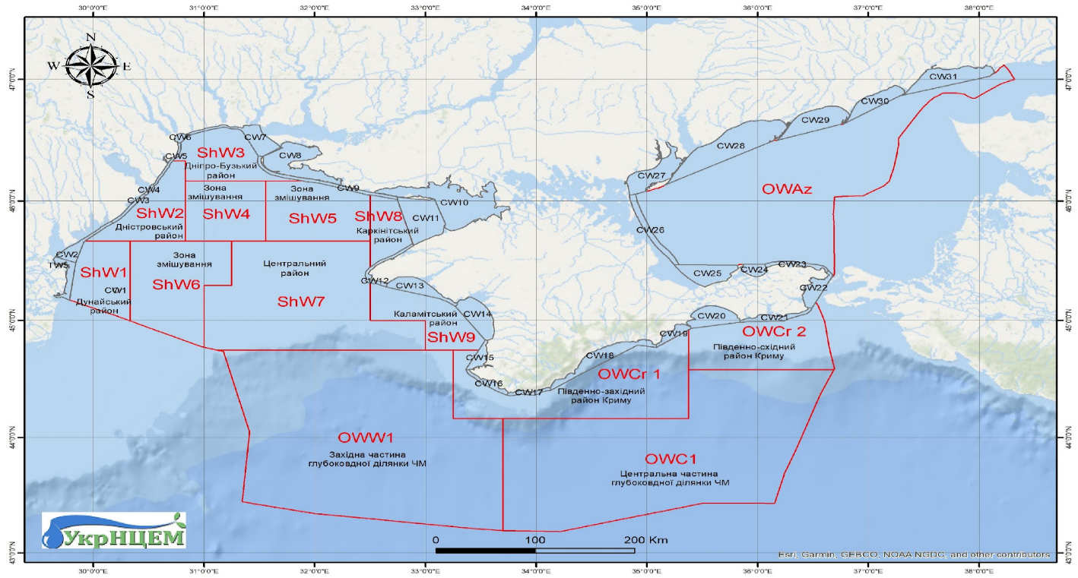
Figure 3.1 – Areas of the Black and Azov seas of Ukraine
The scale of ecological assessment of shelf water bodies and water bodies of the open sea according to the Kz indicator is divided into two classes that correspond to good ecological status (GES) and do not correspond to GES (table 3.2).
Table 3.2 – Status of the quality of shelf water bodies and water bodies of the open sea by the content of pollutants
Quality status  water masses | Indicator Kz | Quality status in color coding
Quality status  water masses | Pollutants in seawater | Quality status in color coding
Good, GES | ≤1,0
Bad, not GES | >1,0
In 2023, ecological monitoring of pollutants was carried out in water bodies СW2 and СW5 according to the coordinates given in Table 1.1 and Figure 1.1. After the explosion of the Kakhovka HPP dam with the help of the volunteer organization "All-Ukrainian Youth Movement "Let's do it Ukraine", additional studies of water and bottom sediments were carried out in order to assess the consequences of the disaster.

3.1 Ecological assessment of the state of seawater in the studied water bodies of the Black Sea according to the content of toxic metals

Table 3.3 shows the average concentrations of TM in the studied water bodies of the Black Sea in 2023.
Table 3.3 – Average concentrations of toxic metals in the Black Sea in 2023.
 | Cd | Hg | Pb | Ni | Cr | As | Co | Cu | Zn
Area | µg/L | µg/L | µg/L | µg/L | µg/L | µg/L | µg/L | µg/L | µg/L
CW2 | 0 | 0,04 | 0 | 0 | 0 | 1,08 | 0 | 27,2 | 55,3
CW5 | 0,32 | 0 | 0,57 | 1,61 | 0,32 | 0,23 | 0,17 | 3,22 | 32,2
As can be seen from table 3.3, in the surface layer of sea water, such metals as copper and zinc are present in significant concentrations. High concentrations of these metals are typical for NWPBS within the territorial waters of Ukraine, but they have an impact on the overall assessment of the ecological state of seawater.
According to the analysis of the TM content in seawater in 2023, the status of the coastal water body CW2 and CW5 corresponds to a very poor ecological condition. Table 3.4 and Figure 3.2 present Kz values for mercury (Hg), cadmium (Cd), lead (Pb), nickel (Ni), chromium (Cr), arsenic (As), cobalt (Co), copper (Cu), zinc (Zn) and the Kz value in general for TM in the surface layer of water. The assessment of the ecological status was carried out in accordance with the EU directive 2013/39/EU (MAC-EQS) supplemented from the NORMAN database (NORMAN Ecotoxicology Database (norman-network.com)).
Table 3.4 – Ecological condition of coastal water bodies according to the Kz TM indicator of the surface layer of sea water by district in 2023.
Area | Кz ТМ | Кz Cd | Кz Hg | Кz Pb | Кz Ni | Кz Cr | Кz As | Кz Co | Кz Cu | Кz Zn
CW2 | 158 | 0 | 0,63 | 0 | 0 | 0 | 1,8 | 0 | 1360 | 55,3
CW5 | 21,6 | 0,21 | 0 | 0,04 | 0,05 | 0,01 | 0,38 | 0,62 | 161 | 32,2

The given summary characteristics of the ecological state of water bodies according to the Kz TM indicator indicate that the ecological state does not correspond to the GES (very bad). According to the indicators of TM groups, the largest contribution in the investigated areas of water bodies is the concentration of copper and zinc (Fig. 3.3).

Figure 3.2 – Pollution coefficient Kz TM of sea water in the areas of coastal water bodies of the NWBS in 2023

Figure 3.3 – Contribution of Kz of individual TMs to the total amount of seawater pollution of TMs in the area of coastal water bodies of the NWBS in 2023

3.2 Ecological assessment of the state of seawater in the studied water bodies of the Black Sea by the content of organic pollutants of agricultural origin

Table 3.5 shows the average concentrations of OPAO in the studied water bodies of the Black Sea in 2023.
The presence of DDT and its metabolites is observed in seawater (Table 3.5), although its use is prohibited by the Stockholm Convention of February 7, 1997.

Table 3.5 – Average concentrations of OPAO in the Black Sea in 2023.
Area | DDT¹ | ∑DDT | β-HCH³ | γ-HCH⁴ | ∑HCH⁵ | Hexachlorobenzene | Heptachlor | ∑ Cyclodiene⁶
 | нг/л | нг/л | нг/л | нг/л | нг/л | нг/л | нг/л | нг/л
CW2 | 1,64 | 1,64 | 0,4 | 0 | 0,76 | 0,31 | 0,16 | 0,88
CW5 | 2,16 | 3,92 | 0,41 | 0,21 | 1,23 | 1,07 | 0,46 | 2,31
Note 1. P, p-dichlorodiphenyltrichloroethane.
Note 2. Sum of DDT and its metabolites.
Note 3. Beta hexachlorocyclohexane.
Note 4. Gamma hexachlorocyclohexane (Lindane).
Note 5. Sum of lindane and its isomers.
Note 6. Sum of aldrin, dieldrin and endrin.
The evaluations of the ecological state of sea water in 2023 in areas CW2 and CW5 of coastal water bodies according to the pollution coefficient Kz with organic pollutants of agricultural origin indicate that their state varies from very good to very bad. The main pollutant among the OPAO group is heptachlor. According to the Kz indicator, heptachlor in the surface layer of water corresponds to the "very bad" ecological condition, which is shown in Table 3.6 and Figure 3.4. The table and the figure present the Kz values for individual OPAO and the average Kz as a whole for OPAO in the surface layer of water. The assessment of the ecological status was carried out according to the maximum permissible concentrations provided in the EU directive 2013/39/EU (MAC-EQS) supplemented from the NORMAN database (NORMAN Ecotoxicology Database (norman-network.com)).
Table 3.6 – Ecological state of sea water of coastal water bodies of NWPBS according to Kz OPAO indicator in 2023.
Area | Кz ОPAO | Кz DDT | Кz ∑DDT | Кz β-HCH | Кz γ-HCH | Кz ∑HCH | Kz Hexachlorobenzene | Kz Heptachlor | Kz ∑ Cyclodiene
CW2 | 0,73 | 0,16 | 0,07 | 0,02 | 0 | 0,04 | 0,01 | 5,33 | 0,18
CW5 | 2,06 | 0,22 | 0,16 | 0,02 | 0,10 | 0,06 | 0,02 | 15,5 | 0,46

The given summary characteristics of the ecological state of water bodies according to the Kz OPAO indicator indicate that for CW2 the ecological state corresponds to the GES (good), for CW5 the ecological state does not correspond to the GES (satisfactory).
According to the indicators of the OPAO group, the largest contribution in the investigated areas of water bodies is the concentration of heptachlor, which is typical for the territorial waters of Ukraine, and is explained by strict requirements for limiting the concentrations of the highly toxic substance (Fig. 3.5).
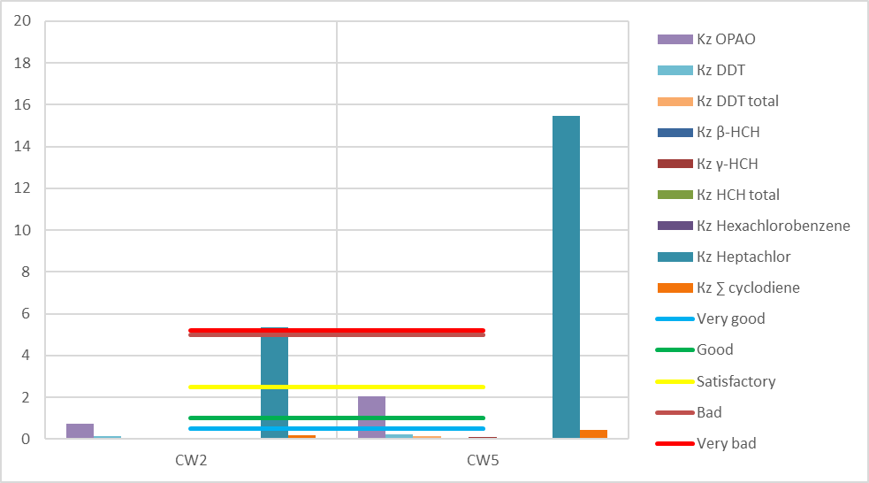
Figure 3.4 – Distribution of the pollution coefficient Kz OPAO of sea water in the areas of coastal water bodies of the NWBS in 2023

Figure 3.5 - Contribution of Kz of individual OPAOs to the total amount of seawater pollution by OPAOs in the areas of coastal water bodies NWBS in 2023

3.3 Ecological assessment of the state of seawater in the studied water bodies of the Black Sea according to the content of organic pollutants of industrial origin

Table 3.7 shows the average concentrations of OPIO in the studied water bodies of the Black Sea in 2023.
According to the average concentrations of OPIO, it can be seen that the CW5 area is under the influence of sources of anthropogenic load of industrial origin, this area also came under a greater load after the explosion of the dam of the Kakhovka hydroelectric power plant (HPP).
Table 3.7 - Average concentrations of OPIO in the Black Sea in 2023.
Area | PCB 101 | PCB 118 | PCB 153 | PCB 138 | PCB 180 | Naphtalene | Anthracene | Fluoranthene | Benzo(b)fluoranthrene | Benzo(k)fluoranthrene | Benzo(a)pyrene | Benzo(g,h,i)perylene
 | ng/L | ng/L | ng/L | ng/L | ng/L | ng/L | ng/L | ng/L | ng/L | ng/L | ng/L | ng/L
CW2 | 0 | 0 | 0 | 0 | 0 | 7,68 | 8,40 | 0,43 | 0,17 | 0,48 | 0,14 | 0,19
CW5 | 2,53 | 0 | 1,54 | 1,58 | 0,10 | 19,4 | 9,07 | 11,0 | 3,88 | 2,34 | 2,48 | 1,75

Assessments of the ecological state of sea water were made in 2023 in areas CW2 and CW5 in coastal water bodies according to the pollution coefficient Kz of organic pollutants of industrial origin, in the surface layer of water corresponds to: CW2 - "very good" ecological state, CW5 - "very bad" ecological state state The environmental condition in the coastal water body CW5 was most affected by the concentrations of individual PCBs 101 and 138, their value of Kz significantly exceeds the threshold level >5.0 of "bad" ecological condition given in Table 3.8 and Figure 3.6.
Also, elevated concentrations were recorded in the surface layer according to the Kz PCB index of 153, which corresponds to a "satisfactory" environmental condition.
Since the 2013/39/EU (MAC-EQS) directive does not have concentration limits for non-dioxin-series PCBs, maximum permissible concentrations for polychlorinated biphenyls (PCBs) were taken from the EAC recommendations, OSPAR SIME 2008.
Kz indicators of polyaromatic hydrocarbons (PAHs) were calculated in accordance with the data of directive 2013/39/ EU (MAC-EQS) supplemented from the NORMAN database (NORMAN Ecotoxicology Database (norman-network.com)).
Table 3.8 – Ecological state of seawater in the areas of coastal water bodies by Kz OPIO indicator in 2023.
Area | Кz OPIO | Кz PCB 101 | Кz PCB 118 | Кz PCB 153 | Кz PCB 138 | Кz PCB 180 | Кz Naphtalene | Кz Anthracene | Кz Fluoranthene | Кz Benzo(b)fluoranthrene | Кz Benzo(k)fluoranthrene | Кz Benzo(a)pyrene | Кz Benzo(g,h,i)perylene
CW2 | 0,03 | 0 | 0 | 0 | 0 | 0 | 0 | 0,08 | 0 | 0,01 | 0,03 | 0,01 | 0,23
CW5 | 17,5 | 126 | 0 | 1,54 | 78,8 | 0,50 | 0 | 0,09 | 0,09 | 0,23 | 0,14 | 0,09 | 2,13
The assessment of the overall characteristics of the ecological state of water bodies according to the Kz OPIO indicators is given according to their worst indicator. In this regard, due to the very high content of PCBs 101 and 138 in 2023 in the CW5 area correspond to "very poor" environmental status.
The performed analysis of polycyclic aromatic hydrocarbons showed that the sum of ∑ PAH, benzo(a)pyrene equivalent (B(a)Peq) and the sum of carcinogenic surfactants (∑ carc PAH) in the water body CW2 are at a much lower level than in the water body CW5, which given in table 3.9 and figure 3.7. the level of PAHs concentrations in the CW5 water body was affected by the disaster after the explosion of the Kakhovskaya HPS dam.
Table 3.9 - Sum of surfactants, benzo(a)perene equivalent and sum of carcinogenic PAH in water bodies of the NWPBS in the surface layer of sea water in 2023.
Area | Ʃ PAH, ng/L | B(a)Peq, ng/L | Σ carc PAH, ng/L
CW2 | 31,4 | 0,56 | 1,06
CW5 | 121 | 7,75 | 14,9

Figure 3.6 – Distribution of the pollution coefficient Kz OPIO of sea water by areas of coastal water bodies of the NWBS in 2023

Figure 3.7 – Average values of ∑ PAH, B(a)Peq and ∑ carc PAH in 2023

Benzo(g,h,i)perylene and anthracene made the largest contribution to seawater pollution by the OPIO group in 2023 in the water body CW2, PCB 101 and 138 were made in CW 5 (Fig. 3.8), this also indicates the influence of pollution leaks of various character.
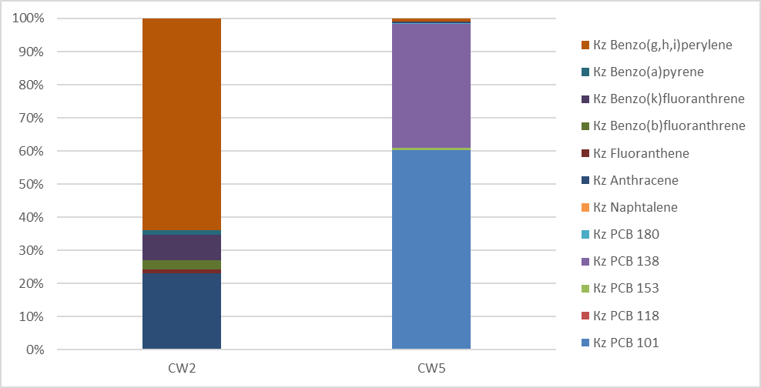

Figure 3.8 – Contribution of Kz of individual OPIO to the total amount of sea water pollution OPIO of coastal water bodies of the NWBS in 2023

3.4 Estimation of the content of petroleum hydrocarbons in seawater in the studied water bodies of the Black Sea

Since the conduct of hostilities caused by the aggression of the Russian Federation significantly affects the ecological state in the Black Sea, additional studies of specific pollutants and the amount of petroleum hydrocarbons (TPH) are required to assess the consequences of the war. Table 3.10 shows the results of studies of the amount of TPH in the water body CW2 and CW5 by month in 2023. The maximum permissible concentrations (MPC) for TPH are taken from the national legislation and are equal to 0.05 mg/dm3.
Table 3.10 – Concentration of TPH in water bodies of the NWBS in the surface layer of sea water in 2023.
Area | Data | Station | TPH, mg/L
CW5 | 18.01.2023 | Black Sea Yacht Club / Yk_1 | 0,07
CW5 | 22.02.2023 | Black Sea Yacht Club / Yk_1 | 0,28
CW5 | 15.03.2023 | Black Sea Yacht Club / Yk_1 | 0,11
CW5 | 13.04.2023 | Black Sea Yacht Club / Yk_1 | 0,18
CW5 | 10.05.2023 | Black Sea Yacht Club / Yk_1 | 0,08
CW5 | 09.06.2023 | Cape M.Fontan / mF_1 | 0,11
CW5 | 14.06.2023 | Black Sea Yacht Club / Yk_1 | 0,10
CW5 | 14.06.2023 | Cape M.Fontan / mF_1 | 0,08
CW2 | 16.06.2023 | village Primorske / S_1 | 0,11
CW5 | 20.06.2023 | 13 st.V.Fountane / bF_1 | 0,27
CW5 | 20.06.2023 | 13 st.V.Fountane / bF_2 | 0,18
CW5 | 05.07.2023 | 13 st.V.Fountane / bF_3 | 0,13
CW5 | 20.07.2023 | Black Sea Yacht Club / Yk_1 | 0,11
CW5 | 20.07.2023 | Cape M.Fontan / mF_1 | 0,11
CW5 | 16.08.2023 | Black Sea Yacht Club / Yk_1 | 0,08
CW5 | 16.08.2023 | Cape M.Fontan / mF_1 | 0,07
CW5 | 21.09.2023 | Black Sea Yacht Club / Yk_1 | 0,26
CW5 | 11.10.2022 | Black Sea Yacht Club / Yk_1 | 0,18
CW5 | 11.10.2023 | Cape M.Fontan / mF_1 | 0,08
CW5 | 16.11.2023 | Black Sea Yacht Club / Yk_1 | 0,22
CW5 | 16.11.2023 | Cape M.Fontan / mF_1 | 0,05
CW5 | 21.12.2023 | Black Sea Yacht Club / Yk_1 | 0,11
As can be seen from Table 3.10, in the CW2 and CW5 water massifs of the NWBS in the surface layer of seawater, the concentrations of TPH exceed the MAC, except for November at the Cape Malyi Fontan station.
Monitoring of possible pollution of seawater in the TPH is also carried out using satellite images.
Figure 3.9 shows the trend of the variability of the concentration of TPH at the sampling stations in the water body CW5.

Figure 3.9 – Variability of TPH concentration at sampling stations
in the water body CW5.
As can be seen from Figure 3.9, in the winter and autumn months of 2023, the concentrations of TPH at the sampling station Yk_1 have peak values, this is due to the location of the sampling station, limited water exchange with the open part of the sea, stormy weather conditions (extraction of bottom sediments) and slowed biological activity (consumption of nutrients). Also, after the blowing up of the Kakhovskaya HPP dam in June, there was a noticeable increase in the concentrations of TPH both at the sampling station mF_1, where there are no obstacles in the water exchange with the open sea, and at the station Yk_1. After the month of August, there is a gradual decrease in TPH concentrations at station mF_1, pollution brought by water after the dam was blown up is decreasing.

3.5 Ecological state of biological objects according to content of pollution

In accordance with descriptor D9 of Commission Decision (EU) 2017/848 and the "Marine Environmental Protection Strategy of Ukraine", an assessment of the presence of toxic substances in aquatic biological resources was carried out. The quality of biological objects was assessed by the degree of content of toxic metals (TM), organochlorine pesticides (OCPs) and polyaromatic hydrocarbons (PAHs).
The scale for assessing the ecological state of aquatic bioresources in coastal water bodies according to the pollution coefficient Kz according to the "Marine Environmental Protection Strategy of Ukraine" is divided into five classes according to toxic metals and organic pollutants (table 3.11).
Table 3.11 – Status of the quality of biological resources of coastal water masses by the content of pollutants
Quality status  water bioresources | Indicator Kz |  | Quality status in color coding
Quality status  water bioresources | TM | Organic substances | Quality status in color coding
Very Good | ≤0,5 | ≤0,2
Good | >0,5 та ≤1,0 | >0,2 та ≤1,0
Satisfactory | >1,0 та ≤1,25 | >1,0 та ≤5,0
Bad | >1,25 та ≤2,5 | >5,0 та ≤25
Very Bad | >2,5 | >25

The scale of ecological assessment of the state of aquatic biological resources in shelf water bodies and water bodies of the open sea is divided into two classes based on the indicator of the pollution coefficient Kz, in which biological resources are characterized by "good" and "poor" condition (table 3.12).
Table 3.12 – State of the quality of biological resources of shelf water bodies and water bodies of the open sea by the content of pollutants
Quality status  water bioresources | Indicator Kz |  | Quality status in color coding
Quality status  water bioresources | TM | Organic  substances | Quality status in color coding
Good, GES | ≤1,0 | ≤1,0
Bad, not GES | >1,0 | >1,0

Since the conduct of monitoring studies in the Black Sea was significantly hindered by hostilities caused by the aggression of the Russian Federation, the study of biological objects in 2023 was carried out to a limited extent, shrimp, mussel, and mullet were studied.
A group of toxic metals

Table 3.13 shows the Kz for TM in samples of biological objects.
The concentrations of metals in the studied samples of biological objects are at the level of a very good ecological status (Table 3.13).

Table 3.13 – Kz TM in the researched biota samples in 2023.
Date | Biological object | KzCd | KzHg | KzPb
august | Shrimp | 0,02 | 0 | 0,14
july-august | Mussel | 0,10 | 0,31 | 0,06
jule | Mullet | 0,40 | 0,40 | 0

Figure 3.10 shows the distribution of group Kz TM in samples of biological objects investigated in 2023. It can be seen from the figure that no concentrations of metals capable of negatively affecting them were detected in the investigated objects.

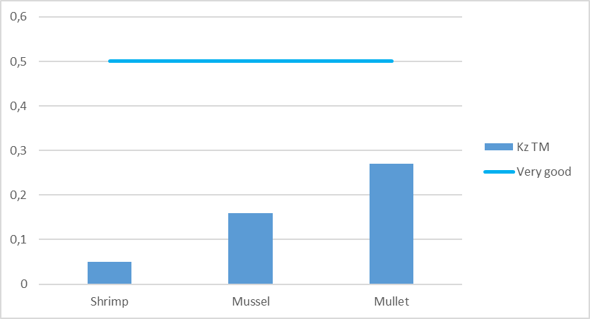
Fig. 3.10 – Kz TM in samples of biological objects researched in 2023.

According to the Kz indicators of individual metals of the TM group, Figure 3.11, the largest contribution to the level of TM contamination in the studied samples of biological objects is attributed to the concentration:
- in Shrimp - lead;
- Mussel - mercury;
- Mullet - cadmium and mercury.

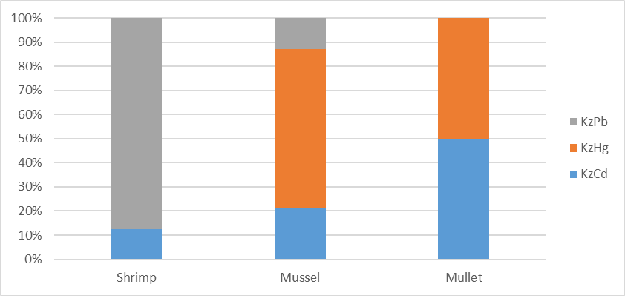
Fig. 3.11 – Contribution of Kz of individual TM to the total amount of contamination of biological objects of TM in 2023.

A group of polluting substances of agricultural origin

Table 3.14 shows the Kz for PAO in samples of biological objects.
It can be seen from Table 3.14 that the concentrations of individual PAO substances are at the level of very bad and bad environmental status:
- in the Mullet sample, namely Heptachlor, HCH total, Lindane;
- in the Mussel samples the level of bad environmental status has Heptachlor concentrations.
Figure 3.12 shows the distribution of group Kz PAO in samples of biological objects researched in 2023. It can be seen from the figure that in the Mullet samples PAO group pollutants are accumulated much more than in the samples of other biological objects.
Table 3.14 – Kz PAO in the researched water samples in 2023.
Date | Biological object | Kz DDE | Kz DDD | Kz DDT | Kz γ-HCH (Lindane) | Kz HCH total | Kz Heptachlor | Kz Hexachlorobenzene | Kz Aldrin | Kz Dieldrin
agust | Shrimp | 0 | 0,05 | 0 | 0 | 0 | 0 | 0 | 0,06 | 0
jule-agust | Mussel | 0 | 0,03 | 0,02 | 0,36 | 0,63 | 5,88 | 0,01 | 0,25 | 0
jule | Mullet | 0,01 | 0 | 0 | 5,23 | 14,75 | 1627 | 0,25 | 2,05 | 0,11

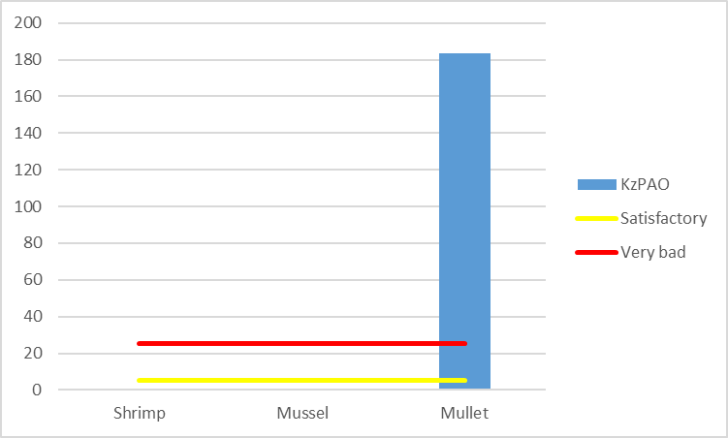
Fig. 3.12 – Kz PAO in samples of biological objects researched in 2023.

According to the Kz indicators of individual compounds of the PAO group, Figure 3.13, the largest contribution to the level of PAO pollution in the studied samples of biological objects is attributed to:
Shrimp – Aldrin and DDD;
Mussel – Heptachlor;
Mullet – Heptachlor.
Figure 3.13 shows that pollution in all selected samples of biological objects has a different character, although Heptachlor has the main influence in Mussel and Mullet samples.

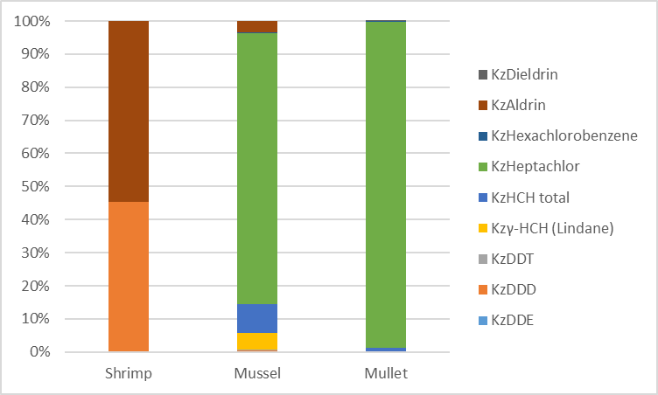
Fig. 3.13 – Contribution of Kz of individual PAOs to the total pollution of PAO biological objects in 2023.

A group of polluting substances of industrial origin

Table 3.15 shows the Kz for PIO in samples of biological objects.
Table 3.15 – Kz PIO in the researched samples of biological objects in 2023.
Date | Biological object | Kz Sum of PCB28, 52, 101, 138, 153, 180 | Kz Sum of dioxins and dioxin-like PCBs | Kz Naphthalene | Kz Phenanthrene | Kz Anthracene | Kz Fluoranthene | Kz Benzo(a)anthracene | Kz Chrysene | Kz Benzo(b)fluoranthrene | Kz Benzo(k)fluoranthrene | Kz Benzo(a)pyrene | Kz Indeno(1,2,3cd)pyrene | Kz Benzo(g,h,i)perylene
august | Shrimp | 0,01 | 17,6 | 0,60 | 1,77 | 0,22 | 6,35 | 12,3 | 66,7 | 19,7 | 27,7 | 1,82 | 0 | 510
july-august | Mussel | 0 | 41,3 | 0,57 | 1,43 | 0,14 | 4,45 | 10,1 | 78,9 | 19,5 | 10,4 | 0,31 | 67,7 | 178
july | Mullet | 0,06 | 97,0 | 0,21 | 9,70 | 0,19 | 4,48 | 0 | 19,2 | 0 | 0 | 1,14 | 609 | 0
As can be seen from Table 3.15, all samples of biological objects are highly contaminated with individual PIOs, their concentrations are at the level of very bad and bad ecological status.
Figure 3.14 shows the distribution of group Kz PIO in samples of biological objects investigated in 2023. It can be seen from the figure that the Kz of the PIO group in all studied biological objects is at the level of very poor ecological status. The level of pollution in biological objects was distributed according to Mullet > Shrimp > Mussel.

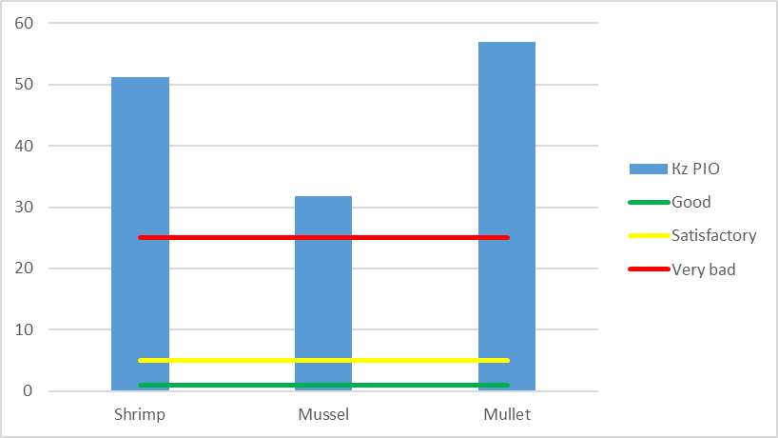
Fig. 3.14 – Kz PIO in samples of biological objects researched in 2023.

According to the Kz indicators of individual compounds of the PIO group, Figure 3.15, the greatest contribution to the level of PIO pollution in samples of biological objects is the concentration of:
Shrimp – Benzo(g,h,i)perylene;
Mussel – Benzo(g,h,i)perylene, Chrysene, Indeno(1,2,3cd)pyrene;
Mullet – Indeno(1,2,3cd)pyrene, Sum of dioxins and dioxin-like PCBs.
It can be seen from Figure 3.15 that pollution of individual PIOs accumulates in different biological objects in different ways.

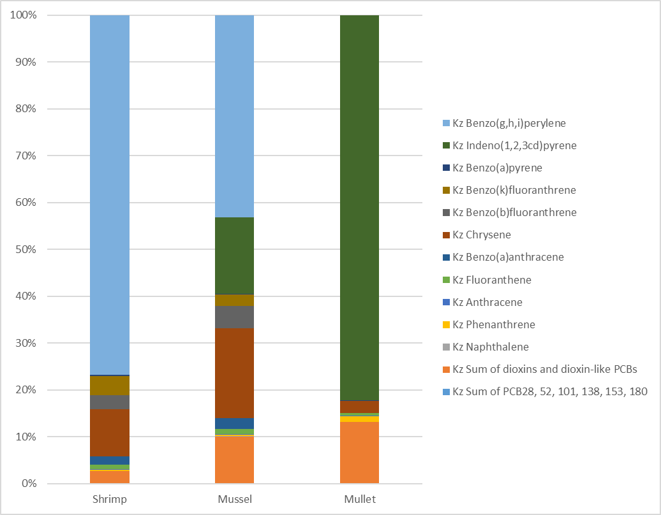
Fig. 3.15 – Contribution of Kz of individual PIOs to the total amount of pollution of biological objects of PIOs in 2023.

General ecological assessment of the studied biological objects

Table 3.16 shows Kz for TM, PAO and PIO in biological objects and assessment of the level of contamination of biological objects.
Table 3.16 – Kz ТМ, PAO and PIO in the reseaerched samples of biological objects in 2023.
Biological object | Kz TM | KzPAO | Кz PIO | External assessment of biological objects
Shrimp | 0,05 | 0,01 | 51,1 | Very bad
Mussel | 0,16 | 0,8 | 31,8 | Very bad
Mullet | 0,27 | 183 | 57,0 | Very bad
Table 3.17 shows the indicators of contamination of samples of biological objects with polyaromatic hydrocarbons (PAHs), namely the sum of PAHs (Ʃ PAH's), benzo(a)pyrene toxicity equivalent (B(a)Peq), the sum of carcinogenic PAHs (Σ carcinogenic PAH's).
These indicators were calculated based on the average concentration of surfactants in samples of biological objects.
Table 3.17 – Indicators of contamination of samples of biological objects with surfactants.
Biological object | Ʃ PAH’s | B(a)Peq | Σ carcinogenic PAH’s
Shrimp | 327 | 26 | 15,8
Mussel | 224 | 12 | 7,57
Mullet | 2292 | 34,4 | 31,9

The Ʃ PAH’s indicator, which characterizes the degree of surfactant pollution, indicates that surfactants significantly accumulate in the studied biological objects and are the main pollutants;
The indicator B(a)Peq, which characterizes the level of toxicity of surfactant pollution, indicates that surfactants accumulate in larger quantities in biological objects of the highest stage of the food chain;
The Σ carcinogenic PAH’s indicator, which characterizes pollution with carcinogenic PAHs, indicates that biological objects contain carcinogenic substances sufficient for the possible development of genetic diseases.

4 ASSESSMENTS of biodiversity and coastal communities of the North-West Black Sea region

Introduction
Up-to-date information was obtained and an assessment and diagnosis of the state of pelagial and benthic hydrobiont communities of the Black Sea coastal areas, which are distinguished by high biodiversity, was performed.
The state of biodiversity of planktonic and benthic communities of marine ecosystems was conducted in accordance with the criteria specified in the EU Directives.

Phytoplankton.
In 2023, 181 species and supraspecific taxa of planktonic microalgae belonging to 12 classes were identified: Bacillariophyсеae (83 species), Dinophyceae (40), Cyanophyceae (20), Chlorophyceae (26) and the remaining 12 species distributed among 8 classes. (Figure 4.1).

Figure 4.1 – Contribution of the main classes of phytoplankton to the total diversity of microalgae species in the Odesa region in 2023

The basis of species diversity was diatom (46.1%) and dinophyte (22.2%) algae.
Throughout the year, salinity fluctuations in the studied water area were the main significant factor in the change of dominant species in the phytoplankton community.
When water salinity decreased, an increase in the number of freshwater algae was recorded: green, cyanobacteria, and dinophytes.
As salinity increased, diatoms dominated.
During the year, several increases in the quantitative indicators of microalgae were noted: at the beginning of March, a bloom of cold-loving dinophyte algae was recorded Ch. lomnickii (Woloszynska) S.C. Craveiro, A.J.Calado, N.Daugbjerg, Gert Hansen & Ø.Moestrup, 2011.
at the end of May, the development of diatom nanoplankton took place Ch. throndsenii (Marino, Montresor & Zingone) Marino, Montresor & Zingone, 1991.
in June, a significant increase in the number of freshwater cyanobacteria complex was noted, with the dominance of three species A. flos-aquae Ralfs ex Bornet & Flahault, 1886, D. flos-aquae (Brébisson ex Bornet & Flahault) P.Wacklin, L.Hoffmann & J.Komárek, 2009 та M. aeruginosa (Kützing) Kützing, 1846).
The quantity of microalgae during the year varied from 10.9 thousand cells. • l⁻¹ to 9427.8 thousand cl. • l⁻¹, biomass from 24.8 mg• m⁻³ to 10436.7 mg• m⁻³, with an average annual population of 904.1 thousand cells. • l⁻¹ and biomass 758.5 mg • m⁻³.
The Shannon index of species diversity varied from 1.8 bits • ex⁻¹ to 3.5 bits • ex⁻¹, with an average value of 2.7 bits • ex⁻¹.
The assessment of water quality was carried out according to a scale according to which the main parameter of phytoplankton indicators is its biomass.
BAC: DIN (spring), МЕС % (summer) and Menhinick indices were also used to assess the ecological condition and presented in Table. 4.1.
Table 4.1 – Ecological state of the marine environment based on quantitative indicators of phytoplankton
Seasons | Biomass,  mg • m⁻³ | Bac : Din Abund | MEC Abund | Menhinick Abund | Assessment of the condition
XII | 27,27 | 76 | 24,121 | 0,045 | Good
I | 305,30 | 14 | 3,245 | 0,043 | Good
II | 72,79 | 331 | 53,501 | 0,042 | Good
winter | 135,12 | 140,33 | 26,96 | 0,043 | Good
III | 1128,18 | 3,94 | 24,675 | 0,037 | Moderate
IV | 225,62 | 77,36 | 20,248 | 0,031 | Good
V | 572,42 | 55,59 | 27,081 | 0,023 | Good
spring | 642,07 | 45,63 | 24,001 | 0,030 | Moderate
VI | 3777,93 | 27,32 | 41,476 | 0,022 | Poor
VII | 1741,76 | 25,21 | 3,762 | 0,055 | Good
VIII | 179,27 | 11,88 | 44,334 | 0,056 | Moderate
summer | 1899,65 | 21,47 | 29,857 | 0,045 | Moderate
IX | 233,01 | 3,56 | 62,628 | 0,058 | Good
X | 601,50 | 15,87 | 44,672 | 0,044 | Good
XI | 237,66 | 67,43 | 34,821 | 0,104 | Moderate
autumn | 357,39 | 28,95 | 47,37 | 0,068 | Good
Annual average | 758,56 | 59,09 | 32,05 | 0,05 | Good

In general, for the year, according to the criterion of the total biomass of phytoplankton, the condition of the Odesa region can be assessed as «High».
According to the average monthly value of the Menkhinik index, the environmental condition as a whole for the year can be assessed as «Poor».
In general, for the year, according to all four indicators, the water corresponded to «Good» ecological status.

Zooplankton.

As part of zooplankton in 2023, 71 taxa of marine, brackish water and freshwater complexes were identified.
The greatest diversity was noted for Copepoda copepods - 27 taxa, but mostly these were single finds of species not widespread in the region.
The group of rotifers included 13 taxa.
Meroplankton and Varia included 9 and 10 taxa, respectively, of which polychaete larvae, molluscs, balanus, and free-living nematodes were constantly present in the pelagic.
Jellyfish were represented by 5 taxa, Protozoa by 2, they met seasonally, although they could have a short-term significant development.
Trophic zooplankton consisted of representatives of the groups Copepoda, Cladocera, Rotatoria, representatives of meroplankton and other groups of zooplankton.
The average number for 2023 was equal to 80,587 ex. • m⁻³, the minimum values were noted in February - 82 ex. • m⁻³, the maximum density was at the beginning of July –
1,358,443ex. • m⁻³.
Biomass ranged from 0.606 mg • m⁻³ (mid-February) to 4940.893 mg • m⁻³ (second half of July), the average during the study was 304.208 mg • m⁻³ (Fig. 4.2).

Figure 4.2 – The contribution of various taxa to the formation of the quantity and biomass of mesozooplankton in the Odesa region in 2023

The Shannon index of zooplankton diversity in winter averaged 1.030 bits • ex.⁻¹, in spring this indicator was 1.396 bits • ex.⁻¹, in summer it increased to 2.023 bits • ex.⁻¹, in autumn it decreased to 1.839 bits • ex.⁻¹ (Fig. 4.3).
The average value of the Shannon index during the study was 1.735 bits • ex^{.-1}.

Figure 4.3 – Shannon's index (by number) of zooplankton in Odesa region in 2023

According to the target values of the IZI index, the "Bad" ecological status of the research area was noted for almost the entire year (Fig. 4.4).

Figure 4.4 – Seasonal course of the IZI index and assessment of the state of the environment according to zooplankton indicators in 2023

Macrozoobenthos
In 2023, 24 taxa of benthic macroinvertebrates were registered in quantitative samples of the macrozoobenthos of the coast of the Odesa region (experimental depths from 0.5 m to 3 m).
Annelida - 8 species, Arthopoda - 9 species, and Mollusca - 6 species play the most significant role in the formation of the qualitative composition of the macrozoobenthos (Fig. 4.5).

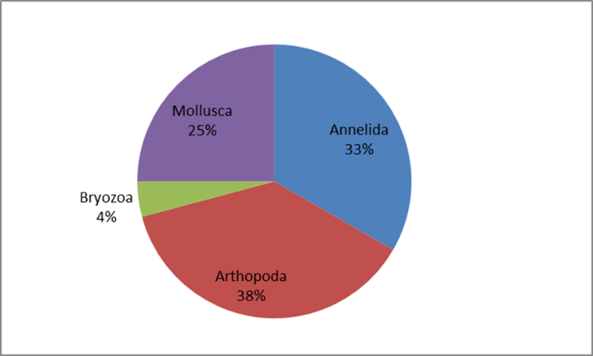

Figure 4.5 – Taxonomic composition of the macrozoobenthos of coastal water bodies in 2023

The following species had the maximum occurrence: Capitella capitata (Fabricius, 1780), Alitta succinea (Leuckart, 1847), Mysta picta (Quatrefages, 1865), Tubificoides sp., Spio filicornis (Müller, 1776), Mytilus galloprovincialis Lamarck, 1819.
These same species were most often part of dominant and subdominant groups.
The maximum quantity of species was found on the artificial substrate – 13, the minimum on sand – 2, on other soft soils – 10.
Shannon's index varied from 0.5 bit • ex.⁻¹ to 1.6 bit • ex.⁻¹.
For the year 2023, 3 main types of benthic communities were noted.
The community of hard substrates Mytilus galloprovincialis Lamarck, 1819.
The group developed on an artificial solid substrate. The ecological status of the macrozobenthos group meets the criteria good environmental status (GES).
The community of loose substrates Chamelea gallina (Linnaeus, 1758) – Parvicardium exiguum (Gmelin, 1791) – Tubificoides sp.
The ecological status of the macrozobenthos community meets the criteria GES.
The community of loose substrates Polychaeta varia.
The ecological status of the macrozobenthos community does not meet the criteria GES – NotGES.
Dynamics communities corresponds to multi-year

Macrophytobenthos.
A total of 20 species of macrophytobenthos belonging to four divisions: Chlorophyta, Rhodophyta, Ochrophyta, and Tracheophyta were noted during the period of observation.
Green seaweeds predominated in number - 9 species, red algae - 8 species, brown - 2 species, seagrass- 1 species, which accounted for 45%, 40%, 10% and 5%, respectively (Fig. 4.6).
During the period of observation, minor changes in species composition naturally occurred.

Figure 4.6 – Seasonal changes in the biodiversity of macrophytobenthos

According to the saprobiont composition, the share of mesosaprobes in general is equal to 50%, in the second place oligosaprobes – 30%, polysaprobes – 20% (Fig. 4.7).

Figure 4.7 – Saprobionts composition of macro phytobenthos by seasons

The share of mesosaprobes by season remains constant, but as the temperature increases, the percentage of oligosaprobes slightly decreases, and the percentage of polysaprobes increases.
This is due to an increase in the content of biogenic substances that contribute to the development of polysaprobe species and, conversely, a decrease in oligosaprobes.
The predominance of the mesosaprobic group of algae in the composition indicates the average level of pollution of the studied water area.
The average biomass of macrophyte populations varied from 0.002 kg·m-2 to 1.783 kg·m-2.

Macrophytobentos indicators recommended for Ecological Status Class (ESC) of the studied water area (classification scheme for 5 ESC correspond to MSFD): three dominants activity (S/W_{3Dp}), m².kg⁻¹, community activity (S/W_{xcom}), m².kg⁻¹, phytocoenoses Surface Index (SI_{ph}) (Tab.4.2).

Table 4.2 – Ecological Evaluation Indexes of macrophytobentos recommended for Monitoring
ESC | EEI range
ESC | S/W_{3Dp}, m².kg⁻¹ | EQR | S/W_{x}, m².kg⁻¹ | EQR | SI_{ph} , units | EQR
High | (S/W)_{3Dp} < 15 | ≥ 0.82 | (S/W)_{x} < 60 | ≥0.98 | SI_{ph} < 25 | ≥ 0.95
Good | 15 ≤ (S/W)_{3Dp} ≤ 30 | 0.54 | 60 ≤ (S/W)_{x} ≤ 80 | 0.79 | 25 ≤ SI_{ph} ≤ 40 | 0.84
Moderate | 31 ≤ (S/W)_{3Dp} ≤ 45 | 0.37 | 81 ≤ (S/W)_{x} ≤ 120 | 0.58 | 41 ≤ SI_{ph} ≤ 55 | 0.68
Poor | 46 ≤ (S/W)_{3Dp} ≤60 | 0.25 | 121 ≤ (S/W)_{x} ≤200 | 0.17 | 56 ≤ SI_{ph} ≤90 | 0.15
Bad | (S/W)_{3Dp} > 60 | ≥0 | (S/W)_{x} > 200 | ≥0 | SI_{ph} > 90 | ≥0

For assessment the comparative spatial distribution of ESC is the most revealing morphofunctional indicator - Three Dominants Ecological Activity (S/W_{3Dp}, m²∙kg⁻¹) (Tab.4.3).
He reflects the intensity of the production process which connected with the level of eutrophication and ecological status of marine environmental.
According to this indicator, the district can be classified as «Poor».
Table 4.3 – ESC by the morphofunctional indicator S/W_{3Dp}, m²∙kg⁻¹.
The type of substrate | Month | Dominant species | (S/W_{3Dp}, m²∙kg⁻¹) | Category of ESC
Polypropylene | May | 1. Ulva intestinalis  2. Cladophora vagabunda  3. Polysiphonia denudata | 46,99±1,75 | Poor
Polypropylene | August | 1. Cladophora vagabunda  2. Ceramium elegans  3. Ceramium rubrum | 33,10±1,74 | Moderate
Concrete | May | 1. Ulva intestinalis  2. Bryopsis hypnoides  3. Ceramium elegans | 45,04±1,72 | Poor
Concrete | August | 1. Cladophora vagabunda  2. Callithamnion corymbosum  3. Polysiphonia denudata | 89,93±2,78 | Bad
Plastic | May | 1. Ulva intestinalis  2. Bryopsis hypnoides  3. Ceramium elegans | 45,04±1,72 | Poor
Plastic | August | 1. Cladophora vagabunda  2. Ceramium elegans  3. Callithamnion corymbosum | 79,66±2,73 | Bad
Sand | May | 1. Ulva flexuosa  2. Ceramium elegans  3. Ectocarpus siliculosus | 66,56±2,48 | Bad
Sand | August | 1. Ulva flexuosa  2. Ceramium elegans  3. Nanozostera noltei | 32,11±1,6 | Moderate

According to the integral result of the assessment of the ESC, the research area can be attributed to the «Moderate».
The following morpho-functional indicators were selected for the evaluation of ESC in two categories of GES (Good Environmental Status)– NotGES (not Good Environmental Status) three morphological and functional indicators: Three Dominants Ecological Activity -S/W_{3Dp}; Average Species Ecological Activity - S/W_{x}; Sensitive species - S_{sp}.(Tab.4.4).
The condition of this water area is closer to GES, except for the percentage of sensitive species.

Table 4.4 – Assessment of the ecological state of the water area by category GES – NotGES
The type of substrate | (S/W)_{3Dp}, м²·кг⁻¹ |  | (S/W)_{x,} м²·кг⁻¹ |  | (S_{sp}), %
The type of substrate | May | August | May | August | May | August
Polypropylene | 46,99 | 33,10 | 64,79 | 58,26
Concrete | 45,04 | 89,93 | 49,55 | 59,24
Plastic | 45,04 | 79,66 | 66,85 | 69,61
Sand | 66,56 | 32,11 | 48,45 | 66,39 | 10 | 5

Microphytobenthos.
During 2023, 143 species of algae belonging to 8 divisions were identified in the microphytobenthos of hard and loose substrates of the studied coastal water area (Fig. 4.8).
Among them, diatoms prevailed - 95 species (66.4% of the total number of species found). These are, for the most part, poly- and mesogalobic and β-mesosaprobic species.

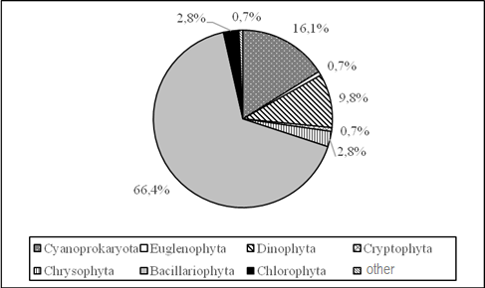
Figure 4.8 – Taxonomic composition of microphytobenthos (% of the number of species found)

Microphytobenthos biomass varied from 238.86 mg ∙ m⁻² to 5102.35 mg ∙ m⁻² on hard substrates and from 446.24 mg ∙ m⁻² to 12126.85 mg ∙ m⁻² on loose substrates.
According to the indicators of the total number of microphytobenthos of hard substrates, the studied areas of the sea were, for the most part, mesotrophic, which fully corresponds to the «good». (Tab.4.5).

Table 4.5 – Assessment of the ecological state of the water area environment according to the scale and classes of trophicity according to numbers microphytobenthos of hard substrates (10⁶ cells ∙ m^{ˉ2})
Sampling location | Scale of trophicity, million cells/m² | 0,10∙10³-0,49∙10³ | 0,50∙10³-14,99∙10³ | 15,00∙10³-49,99∙10³ | 50,00∙10³-199,99∙10³ | ≥200,00∙10³
Sampling location | Classes of trophicity | Oligotrophic High | Mesotrophic Good | Europhic Moderate | Polytrophic Poor | Hypertrophic Bad
concrete pier, near the shore | Spring |  | 3,93∙10³
concrete pier, near the shore | Summer |  | 4,82∙10³
concrete pier, near the shore | Autumn |  | 12,74∙10³
concrete pier,  (3 m from the shore) | Spring
concrete pier,  (3 m from the shore) | Summer |  | 4,88∙10³
concrete pier,  (3 m from the shore) | Autumn
A stone near the shore | Spring |  | 1,48∙10³
A stone near the shore | Summer
A stone near the shore | Autumn
Plastic, (pontoon) | Spring |  | 2,26∙10³
Plastic, (pontoon) | Summer |  | 3,76∙10³
Plastic, (pontoon) | Autumn |  | 3,75∙10³

5. Eutrophication

The range of variations in the content of nutrients in the region CW5 of national waters of Ukraine in 2023 is presented in the figures (Fig. 5.1 – 5.4).

According to long-term observations in 2000-2023 in the coastal water body СW5 of the Odesa region of the Black Sea there is a tendency to decrease the mineral (DIP) and total phosphorus (TP). The average annual content of mineral phosphorus in this period varied from 23,9 μg/dm³, at the beginning of the XXI century, to 9,3 μg/dm³ in 2015 (Fig. 5.1). In the last five years, the average annual content of mineral phosphorus in coastal waters in this area has ranged from 10,6 μg/dm³ to 15,5 μg dm³, with an average of 12,4 μg/dm³. The level of average annual values of the concentration of mineral phosphorus in the recreational zone of the water body СW5 corresponds to a good ecological condition at the value of GES 16,4 μg/dm³.

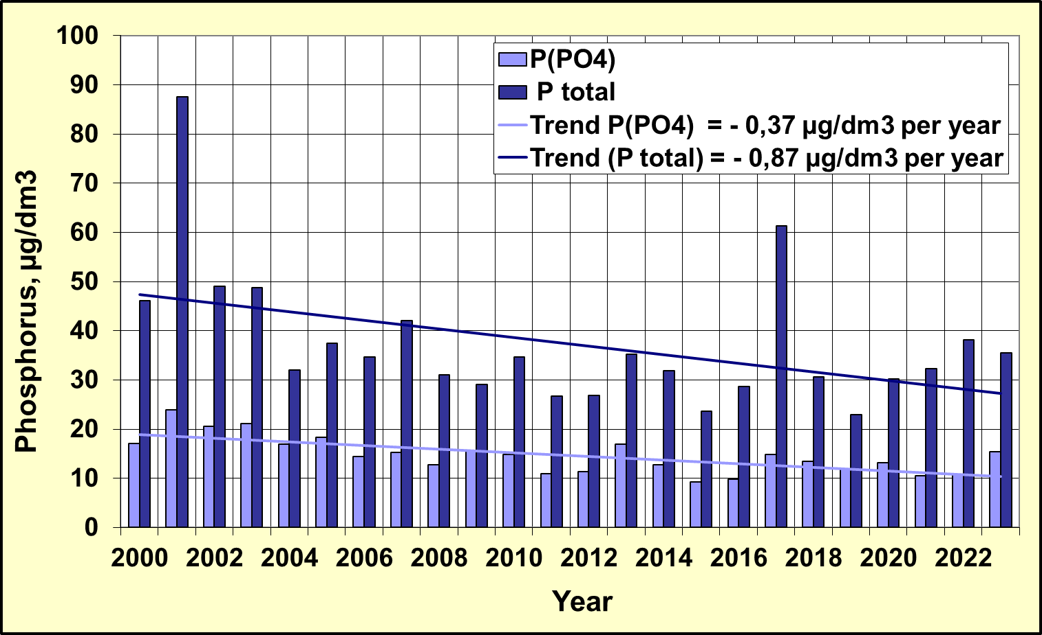
Figure 5.1 - Long-term changes in the content of mineral and total phosphorus in the coastal water body CW5 in the recreational zone of the city of Odesa

In the multi-year plan of 2000 - 2023, the content of the average annual amount of mineral forms of nitrogen (DIN) in the coastal water body СW5 of the Black Sea shows a tendency to decrease its concentration from 182,9 μg/dm³ in 2001 to 47,7 μg/dm³ in 2020 (Fig. 5.2), however, over the past four years, concentrations have increased from 47.7 μg/dm³ in 2020 to 286.4 μg/dm³ in 2023. In 2023, according to the indicator of the average annual concentration of DIN, coastal waters in this area did not correspond to GES (52.7 μg/dm³). The general tendency to decrease the content of DIN in the period 2000-2022 was -2.54 μg/dm³ per year, and with the year 2023 it is -0.28 μg/dm³ per year.
In contrast to the sum of mineral forms of nitrogen, the average annual content of total nitrogen in the period 2000-2023 reveals a tendency to increase its content due to the organic component. The average annual concentration of TN during this period in the coastal body of water СW5 ranged from 335 μg/dm³ in 2002 to 3083 μg/dm³ in 2023. The ratio Norg./Nmin. gradually increased from 1.7 in 2001. to 10.6 in 2019, in 2023 this ratio was 10 units. In the last five years, the average annual TN content ranged from 522 μg/dm³ to 3083 μg/dm³, with an average value of 1128 μg/dm³. In 2023, the average annual TN content of 3083 μg/dm³ in the water body CW5 did not correspond to the GES level (314 μg/dm³) and was abnormally high due to its organic component, which is obviously related to the influence of military actions on the state of surface watercourses flowing into the Black Sea.

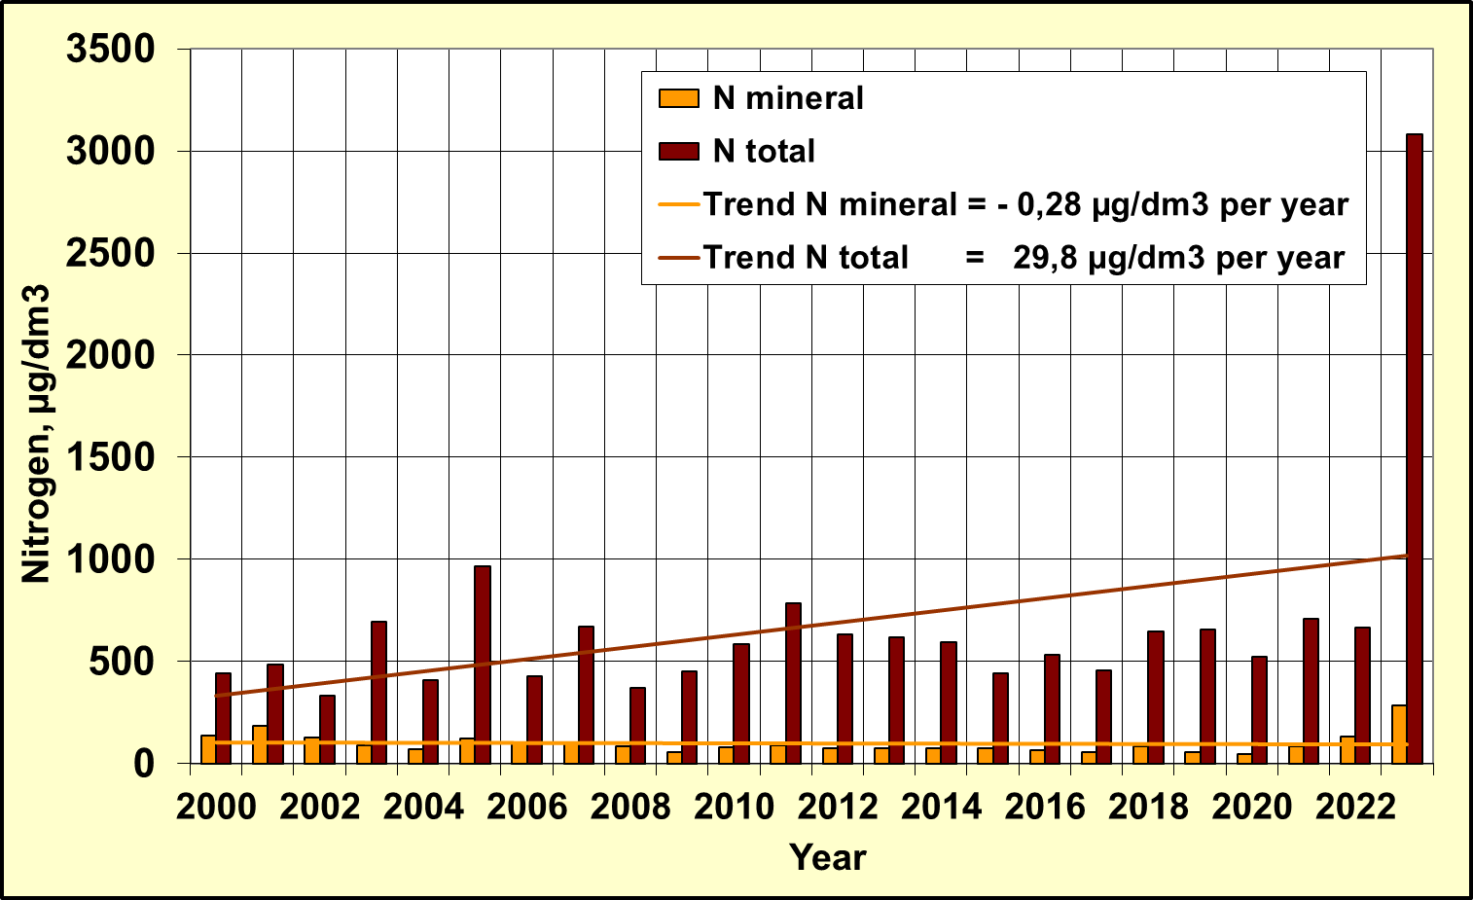
Figure 5.2 - Long-term changes in mineral and total nitrogen content
in the coastal water body СW5 in the recreational zone of the city of Odesa

The tendency to decrease the content of mineral compounds of nitrogen is determined by its individual indicators of nitrite, nitrate and ammonium nitrogen, which is shown in Figure 5.3.

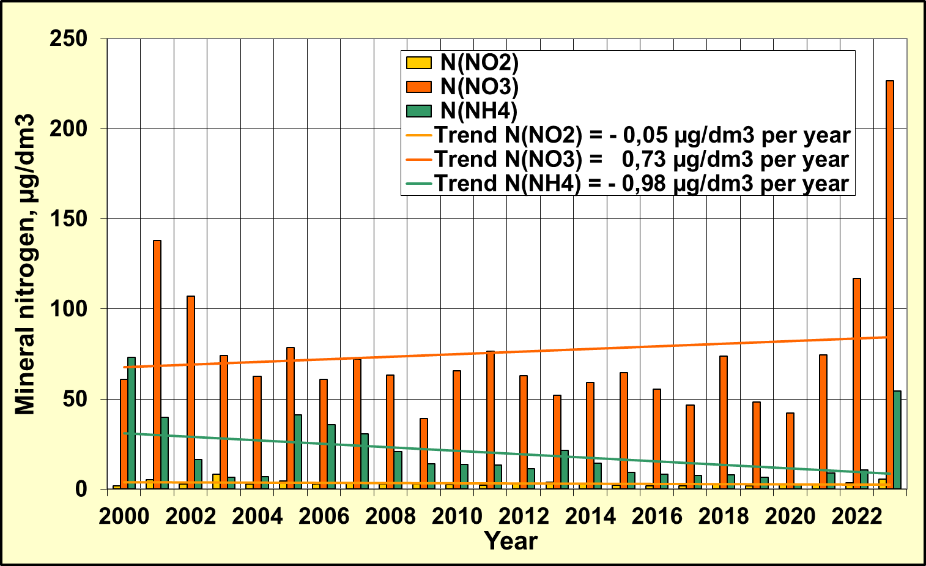
Figure 5.3 - Long-term changes in the content of mineral forms of nitrogen in the coastal water body СW5 in the recreational zone of the city of Odesa

In the long-term variability of biogenic substances, according to the data of regular observations in the coastal waters of the Odesa region since the beginning of 2000, there was a trend towards a decrease in the average annual concentration of phosphate and total phosphorus, mineral forms of nitrogen and, accordingly, a decrease in the trophicity of the coastal waters of the CW5 massif in the period 2000-2015. In 2015-2023, the stabilization of the trophicity of the waters of the CW5 massif is observed at the level of 4.52 units. up to 5.14 units and corresponds to the "moderate" level of trophicity with the value of the average TRIX index = 4.89 units, which is shown in Figure 5.4.

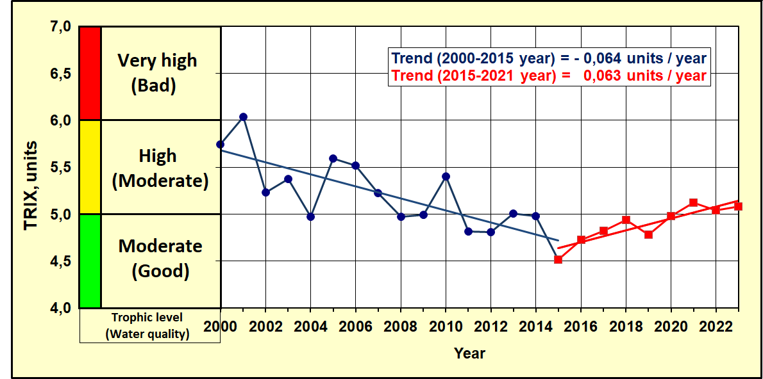
Figure 5.4 – The long-term changes of trophicity and quality of the coastal waters
of Odesa region of NWBS by TRIX index

6. Other activities of the RAC PMA

6.1 Overview of monitoring data flows to the RDB-P by Ukraine in 2023 years

Table 6.1 Statistics of the sample types by years
 |  | 2013 | 2014 | 2015 | 2016 | 2017 | 2018 | 2019 | 2020 | 2021 | 2022 | 2023
Ukraine | BathingWater | - | - | - | - | - | - | - | - | - | - | -
Ukraine | Biota | + | + | + | + | + | + | + | + | - | - | +
Ukraine | Sediment | + | + | + | + | + | + | + | + | + | + | -
Ukraine | Water | + | + | + | + | + | + | + | + | + | + | +

Table 6.2 Statistics of the number of parameter groups by years (water, sediment, biota)
Ukraine |  |  | SampleType-Water
ParameterGroup/Year | 2013 | 2014 |  | 2015 | 2016 | 2017 | 2018 | 2019 | 2020 | 2021 | 2022 | 2023
Detergents |  | 1
Hydrochemistry | 6 | 6 |  | 6 | 7 | 7 | 7 | 7 | 6 | 6 | 4 | 4
Hydrology | 2 | 2 |  | 2 | 2 | 2 | 2 | 2 | 2 | 2 | 2 | 2
Nutrients | 7 | 7 |  | 7 | 7 | 7 | 7 | 7 | 7 | 7 | 7 | 7
PAHs |  |  |  |  | 16 | 17 | 17 | 18 | 18 | 18 | 16
PCBs | 19 | 19 |  | 22 | 23 | 23 | 23 | 32 | 26 | 34 | 34 | 37
Pesticides | 13 | 13 |  | 12 | 12 | 12 | 12 | 14 | 14 | 14 | 14 | 11
Petroleum Hydrocarbons | 1 | 1 |  | 1 | 1 | 1 |  | 1 |  |  |  | 1
Phenols
Photosynthetic pigments
Radionuclides
Trace (heavy) metals | 11 | 11 |  | 10 | 11 | 10 | 10 | 10 | 10 | 10 | 10 | 10

Ukraine | SampleType- sediment
ParameterGroup/Year | 2013 | 2014 | 2015 | 2016 | 2017 | 2018 | 2019 | 2020 | 2021 | 2022 | 2023
Detergents
Hydrochemistry | 2 | 2 | 2 | 2 | 2 | 2 |  |  | 2
Nutrients
PAHs |  |  |  | 16 | 17 | 17 | 18 | 18 | 18
PCBs | 20 | 19 | 21 | 23 | 23 | 31 | 32 | 26 | 34
Pesticides | 13 | 11 | 12 | 12 | 12 | 12 | 14 | 14 | 14
Petroleum Hydrocarbons | 1 | 1 | 1 | 1 | 1 | 1 | 1 | 1 | 1
Phenols | 1 | 1 | 1 | 1 | 1 | 1 | 1 | 1 | 1
Radionuclides
Trace (heavy) metals | 11 | 12 | 10 | 12 | 12 | 11 | 12 | 11 | 12 | 12

Ukraine | SampleType-Biota
ParameterGroup/Year | 2013 | 2014 | 2015 | 2016 | 2017 | 2018 | 2019 | 2020 | 2021 | 2022 |  | 2023
PCBs | 19 | 20 | 23 | 23 | 23 | 30 | 31 | 26 |  |  | 35
Pesticides | 11 | 11 | 12 | 12 | 12 | 12 | 14 | 14 |  |  | 12
Trace (heavy) metals | 10 | 11 | 10 | 11 | 11 | 11 | 11 | 11 |  |  | 11
PAHs |  |  |  | 16 | 16 | 16 | 17 | 18 |  |  | 16

Table 6.3 – Statistics of the number of samples by parameter groups and by years (water)

Ukraine | SampleType-Water
ParameterGroup/  Year | 2013 | 2014 | 2015 | 2016 | 2017 | 2018 | 2019 | 2020 | 2021 | 2022 |  | 2023
Detergents |  | 10
Hydrochemistry | 333 | 210 | 204 | 560 | 807 | 189 | 530 | 204 | 316 | 118 |  | 250
Hydrology | 134 | 212 | 312 | 302 | 409 | 48 | 275 | 124 | 168 | 56 |  | 124
Nutrients | 399 | 646 | 678 | 999 | 1337 | 288 | 957 | 396 | 552 | 217 |  | 427
PAHs |  |  |  | 889 | 1564 | 867 | 1422 | 432 | 486 | 136
PCBs | 384 | 342 | 657 | 1357 | 2139 | 1179 | 2560 | 624 | 1632 | 280 |  | 237
Pesticides | 235 | 214 | 346 | 708 | 1116 | 612 | 1120 | 336 | 630 | 112 | 77
Petroleum Hydrocarbons | 27 | 18 | 4 | 61 | 64 |  | 30 |  | 24 |  | 22
Phenols
Radionuclides
Trace (heavy) metals | 194 | 180 | 480 | 525 | 990 | 509 | 780 | 240 | 480 | 50 | 70

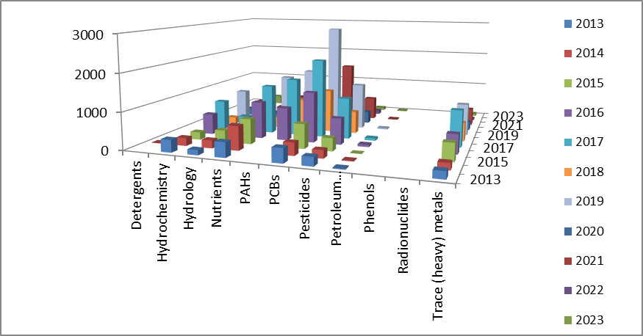
Figure 6.1 - Distribution of the number of samples by parameter groups and years (water)

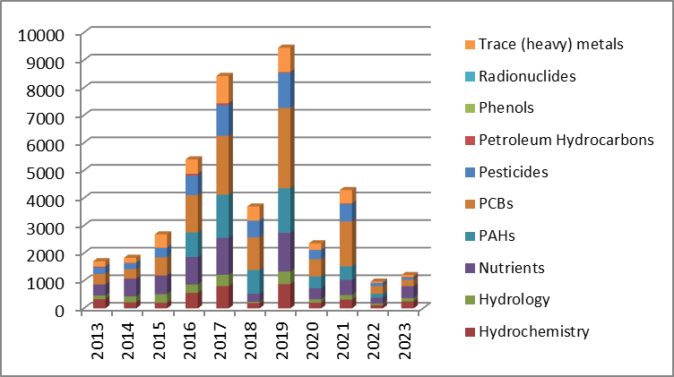
Figure 6.2 - Total numberof samples for each parameters group (water)

Table 6.4 – Statistics of the number of samples by parameter groups and by years (sediment)

Ukraine | SampleType- sediment
ParameterGroup/  Year | 2013 | 2014 | 2015 | 2016 | 2017 | 2018 | 2019 | 2020 | 2021 | 2022 | 2023
Hydrochemistry | 34 | 20 | 56 | 64 | 88 | 24 |  |  | 48
PAHs |  |  |  | 416 | 833 | 442 | 702 | 216 | 198
PCBs | 723 | 266 | 684 | 621 | 1081 | 614 | 1344 | 312 | 888
Pesticides | 415 | 154 | 359 | 324 | 564 | 312 | 582 | 168 | 310
Petroleum Hydrocarbons | 37 | 15 | 26 | 39 | 49 | 24 | 24 | 12 | 24
Phenols | 34 | 10 | 19 | 39 | 44 | 24 | 39 | 12 | 24
Radionuclides
Trace (heavy) metals | 352 | 180 | 330 | 348 | 588 | 312 | 504 | 132 | 288 | 24

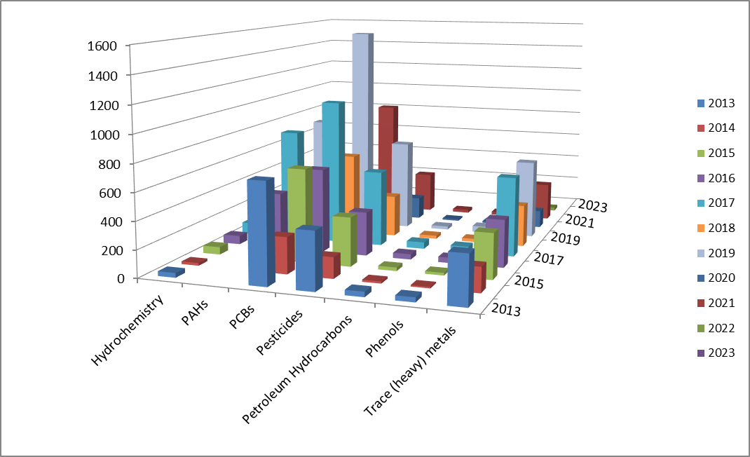

Figure 6.3 - Distribution of the number of samples by parameter groups and years (sediment)

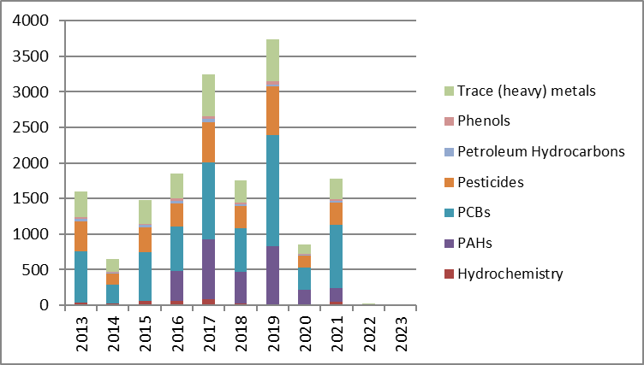
Figure 6.4 - Total number of samples for each parameters group (sediment)

Table 6.5 – Statistics of the number of samples by parameter groups and by years (biota)

Ukraine |  | SampleType-Biota
ParameterGroup/Year | 2013 | 2014 | 2015 | 2016 | 2017 | 2018 | 2019 | 2020 | 2021 | 2022 | 2023
PCBs | 361 | 320 | 128 | 414 | 529 | 120 | 186 | 234 |  |  | 238
Pesticides | 209 | 176 | 69 | 216 | 276 | 48 | 84 | 126 |  |  | 84
Trace (heavy) metals | 193 | 176 | 70 | 190 | 242 | 44 | 77 | 121 |  |  | 77
PAHs |  |  |  | 288 | 368 | 64 | 102 | 162 |  |  | 112

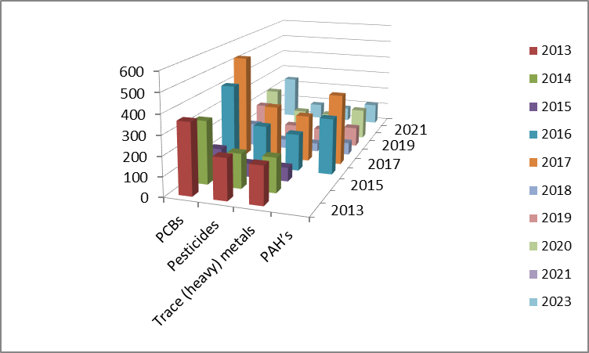
Figure 6.5 - Distribution of the number of samples by parameter groups and years (biota)

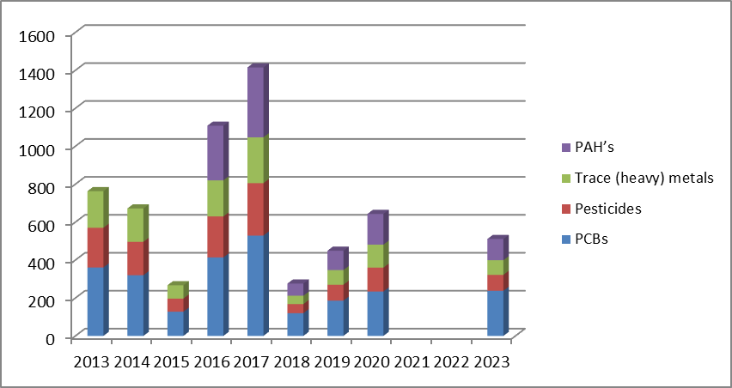
Figure 6.6 - Total number of samples for each parameters group (biota)

